**Ocean&lake shader document**

**Universal renderer pipeline settings**

I have changed two settings:

-Enabled opaque

-Enabled depth

*I also added the pipeline asset in the project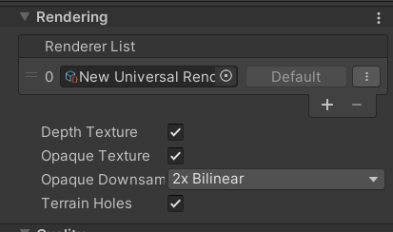

**Ocean parameters:**

Water color1 and 2: the colors of the ocean

Normal tile: the texture tile

Smoothness: how smooth the ocean

Normal speed: the speed of the texture moving on top of the ocean

WaveColor speed: the speed of the color that’s moving on the ocean

Wave strength: the height they go to and how strong they are

Foam speed: the speed of the foam texture changing

Foam distance: how far will the foam go from the object it's touching

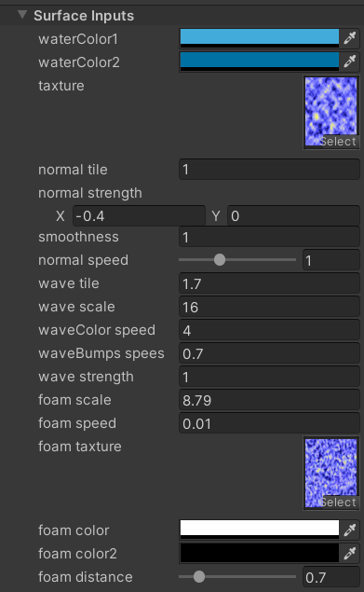

**Lake parameters:**

Shallow/deep colors: the colors of the lake

Water depth: the combination between those colors

Refraction speed: the speed of the texture(refraction) that's moving on top of the lake

Refraction scale: plays with the refraction texture

Refraction strength: how visible is the refraction

Foam scale: plays with the foam texture

Foam distance: how far will the foam go from the object it's touching

